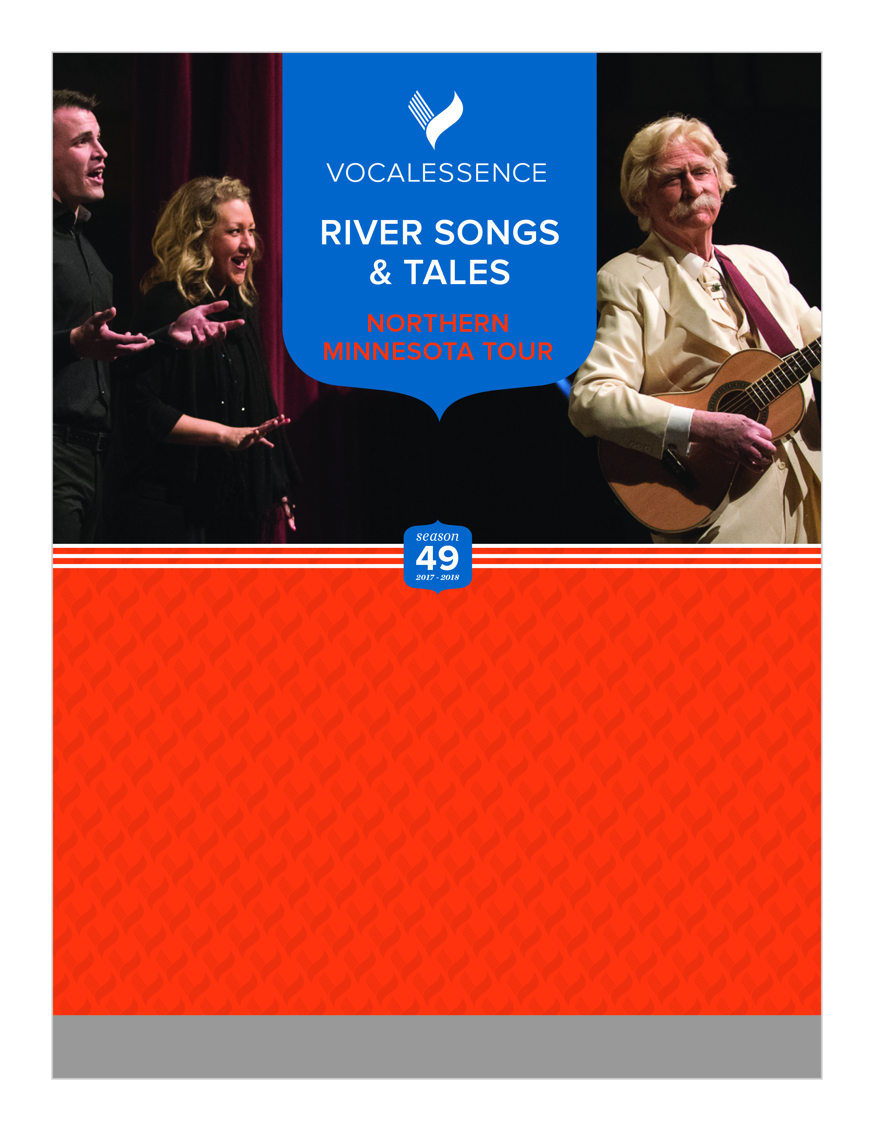

This activity is made possible by the voters of Minnesota through a grant from the Minnesota State Arts Board, thanks to a legislative appropriation from the arts and cultural heritage fund.

**reifcenter.org   |   218-327-5780**

**Wed, Apr 4, 2018 at 7:30 pm**

**Wilcox Theatre in the Reif Performing Arts Center  
720 NW Conifer Drive, Grand Rapids, MN**

**Members of the VocalEssence Ensemble Singers**

**Don Shelby, *Mark Twain***

**Sara Pajunen, *Fiddle***

Supported by an Arts Tour grant from the Minnesota State Arts Board, members of the VocalEssence Ensemble Singers, folk fiddler Sara Pajunen and Don Shelby as Mark Twain go on the road to Northern Minnesota to celebrate life on the Mississippi River. Through choral music and the spoken word, VocalEssence takes listeners on a musical journey of the past and present—choral masterpieces, favorite folksongs, traditional spirituals, and Americana—all paired with the words of Mark Twain.